AP CSP Python with Robots  Mission 4 Obj 1-7 Assignment |  | Name:
Mission 4 Introduction
Read the introduction and project goals. During this assignment, you will complete the first two goals.
Mission 4 Objectives 1-7
Complete Objective 1.
What is a while statement used for?
After completing the code in Objective 1, you observe that you can define a function for sweeping the LEDs, and then call the function in the while loop. This will increase the readability of your code.
Define a function sweep_leds() for the 4 lines of code. Then call the function inside the while loop. Does the function need a parameter?
Complete Objective 2. The code should be added to the main program, and not the function.
What does it mean to “update a variable”?
Give an example of updating a variable:
What is the error message given?
Complete Objective 3. Use the debugger to step through the program and observe the value of the global variables.
What is the difference between a double equals and a single equals?
Complete Objective 4. Add code as instructed in the while loop. Did you notice a sleep(delay) was removed? Delete it from your function.
Complete Objective 5.
What does “increment” mean? Give an example.
Why do you think you turn on the LED before incrementing the counter?
Complete Objective 6. Click on User Interface to add it to the toolbox.
Complete Objective 7. Explain why a button press may count more than once, and how you can fix a bad bounce.
After completing the code in Objective 7, you observe that you can define a function for counting the guests, and then call the function in the if statement for the button press. This will increase the readability of your code.
Define a function count_guests() for the 5 lines of code that beep, debounce and turn on an LED. Then call the function inside the if statement. Does the function need a parameter?
Your main program may look similar to this:
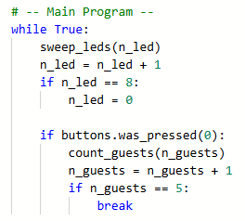
After Objective 7, submit your SweepLEDs program to the teacher.

